My health and wellbeing in prison and beyond 2 (men)

Unit 3
Living with addiction

*

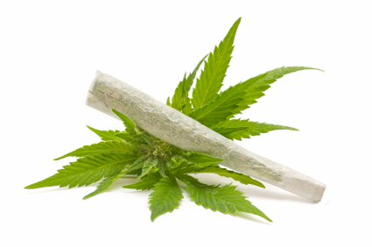
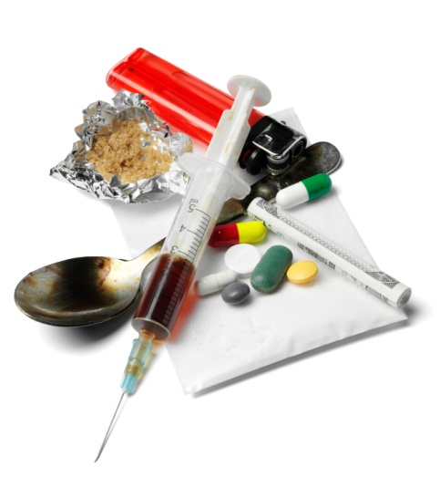

Contents
Unit 3 Living with addiction teachers’ notes

Unit 3 Living with addiction learner resources

Unit 3 Living with addiction answers

Unit 3 Living with addiction video file: Symptoms.mp4

Copyright - please read
All the materials on these pages are free for you to download and copy for educational use only in your establishment. You may not redistribute, sell or place these materials on any other website without written permission from the British Council. If you have any questions about the use of these materials please email us at: esolnexus@britishcouncil.org

Introduction

This unit contains two reading comprehensions based on a case study about someone who struggled with addiction. It introduces useful language for describing life with addictions, some of the effects of drug and alcohol abuse and provides a context for discussion of addiction. It aims to equip learners with the language for understanding how to access help within and on release from prison.

Be sensitive about how much or how little learners wish to share of their personal experiences. If you feel it's more appropriate, you could use literature you have gathered to base discussions about the effects of substance misuse and build these into the session where appropriate.

Level: Entry level 1-3 / Access 2 – National 4 / CEFR A1 - B1

Time:
Approximately 90 minutes. Timings are flexible and teachers can break down the units into smaller chunks of learning and build in revision as required.

Aims
- To introduce key lexis to describe the effects of substance abuse and addiction
- To equip students with the language to access help for addicts in their own institution or on release

Objectives
Entry 1/ 2 learners will be able to:
- understand a wider range of vocabulary to describe the effects of alcohol and drug abuse: choke, shake; shiver; overdose; withdrawal
- read and understand a story set in the past about a drug addict's experiences
Entry 3+ learners will be able to:
- understand phrasal verbs: come down, sent down, feel down, chill out
- read and understand a leaflet about staying safe from overdose on release
- research help for addicts in their own institution and on the outside
- share their findings with the rest of the class

Preparation
You will need:
- Video 'symptoms' and a digital projector or computer for playback
- Resource 1: 1 copy per learner
- Resource 2: 1 copy cut up per pair or small group
- Resource 3: 1 copy per Entry 1 or Entry 2 / 3 learner
- Resource 4: 1 copy per learner
- Resource 5: 1 copy per learner
- some accessible drug information literature from your institution or outside, preferably with illustrations
- sticky notes or some flip chart paper and marker pens
- dictionaries
- answers
Suggested Procedure
Activity 1 – Warmer (10 minutes)
- Elicitation: play the 'symptoms' video from the DVD through once and ask the learners what the symptoms are.
- Hand out resource 1 and focus learners' attention on the list of verbs. Explain these are all action words, for when you feel ill.
- Read through the words and check learners can say them correctly. Drill pronunciation.
- Read through the instructions together and demonstrate numbering by playing the first clip, then asking what it is. Write it on the board, with a number 1.
- Now play the rest of the video while learners tick the correct box.
- Ask learners to check their answers in pairs then feedback to make sure they have the correct answer.
Activity 2 – Pre-reading task plus vocabulary (10 minutes)
- Cover key words which appear in the reading activity: dealer, ecstasy, user.
- Group learners according to level: Entry 2-3 or Entry 1-2 and hand out either sticky notes or marker pens and flip chart paper.
- Elicit the meaning of the word 'addict' by asking questions such as ‘If you need to drink alcohol or take drugs every day, what’s the matter?’ ‘If you feel ill if you don’t have drugs or alcohol, what’s the matter?’ What do we call people who have to drink or take drugs?’ Write the word 'addict' on the board.
- Tell learners to discuss these questions in small groups:
  - What can people become addicted to?
  - What do you call someone who takes drugs? (user)
  - Why do people start taking drugs?
  - What is the name of the drug that some people take to have fun? They may have lots of energy and be very friendly. (ecstasy)
  - What's another word for a person who sells drugs? (dealer)
  - Do you know any words that mean addict?
- They should write their answers on the sticky notes or flip chart paper. You can display these for the learners to compare language now and refer to later in the session.

Differentiation
- For Entry 1-2 learners, the reading text is simplified. Focus on the difference between addict (a person) and addiction (a medical problem).
- Ask them to think of examples of addictions and things you can be addicted to.
- More literate learners could scribe for those who have literacy needs.

Extension Activity (optional): (5-10 minutes)
Resource 2: Positive and negative effects of using alcohol or drugs.
Use this if you have a mainly lower level group for extra vocabulary input before the reading activity. Higher levels may not need this and you could just check their understanding of the following words: dizzy; aggressive; high; confident, e.g. by miming.
- Put learners into pairs or threes.
- Write the first sentence from resource 2 on the board and read it out.
- Check understanding of key word (relaxed) by asking questions such as ‘if you are very busy, are you relaxed?’ ‘If you are scared, are you relaxed? If you are lying down listening to music, are you relaxed?’ use mime if necessary.
- Ask learners if it's a positive or negative feeling.
- Hand out cut-ups of resource 2 to each group. Tell them they are some of the side effects of using drugs and alcohol.
- The learners should sort the sentences into two sets, positive and negative. Allow learners to use dictionaries if necessary/ available.

Activity 3 (10 minutes)
- Display resource 1, task 2 (completing the table).
- Elicit some suggestions for which sentences such as from resource 2 they could use to describe smoking cigarettes or cannabis.
- For the third row, learners should choose another substance they know, and use the sentences from resource 2 or their own ideas to describe the side effects.
Tip! This could be a very sensitive issue for many reasons, especially confidentiality and safeguarding. Make it clear that you are only interested in practising English language for health and illness. They can choose a legal or an illegal substance to write about here.
- If learners are comfortable, they could discuss their suggestions in pairs or small groups.

Activity 4: Reading for gist (10 minutes)
Decide which level of resource 3 is suitable for each learner - either Entry 1 or Entry 2/3. Stages 1-3 are similar, stages 4 and 5 are different.
- Hand out resource 3. Tell learners they are going to read the story of a drug addict. Encourage them to read for gist i.e. not understanding every word or using a dictionary at this stage.
- Now tell them to read the possible titles (resource 3, task 1) and choose the one they think fits best. They should compare with a partner and say why they made that choice. You could ask one or two people about their choices.

Differentiation
- Ideally, learners should sit in groups according to level. Bear in mind some learners may be reluctant to move from their usual places, so sensitively explain the reason for asking them to move.
- The Entry 2-3 learners could choose any of the titles for the answer as they are all appropriate, but they should justify their choice with a point from the text.
- The Entry 1 version has only 1 correct answer (b).

Activity 5 – Reading for main points (10 minutes)
- Focus learners’ attention on task 2 on resource 3. Tell them to read the text again carefully and answer the questions with true or false.
- Monitor during the activity and check the answers together or in pairs.

Differentiation
If necessary, model the true/ false activity by writing an obviously false statement on the board- e.g. It's 7:30 pm, and asking ‘Is it 7:30pm?’ to elicit the response, ‘no’.

Activity 6 – Reading for detail (10 minutes)
- Focus learners’ attention on task 3 on resource 3.
- Tell them to read the text again carefully to find the answers. Decide whether you want the Entry 2-3 learners to write full sentences or not.
- Feed back as a whole class afterwards.

Differentiation
Entry 1 learners have a sentence completion exercise for task 3.

Activity 7 – differentiated task (10 minutes)

Entry 2 / 3: vocabulary in context (resource 3, tasks 4 and 5)
- Focus learners’ attention on task 4 on resource 3 and direct them to the underlined phrasal verbs in the story.
- As a model, read sentence 1 or ask a learner to read it then ask them to choose the correct definition in pairs. Discourage stronger learners from supplying the answer quickly (this is to allow all the learners time to think).
- Nominate a learner to supply the answer.
- Now let them continue then feed back to check afterwards.
- For task 5, read the instruction together and draw their attention to the paragraph numbers in the text on resource 3, to help them find the words in the text.
- Check the answers together afterwards.

Activity 7 – Entry 1: grammar in context
- Focus learners’ attention on task 4 of resource 2. They should look for the example 'I was' in the text.
- They should now look for the other verbs in the text and complete the table. They could also use the verb table in the dictionary, if available.

Tip! If this is a new grammar point, write the year now and the year 25 years ago on the board. Write a sentence about Craig under each date, to highlight the concept of past and present.

- Focus learners’ attention on task 5 on resource 3.
- Do the first sentence together, then let them continue. Remind them that all the verbs are from task 4.
- Check together afterwards.

Extension: Activity 8 – short group discussion
- Focus learners’ attention on task 6 on resource 3.
- Elicit some answers to the questions, then, depending on the class, have learners work in pairs, small groups or as a whole class to continue the discussion.
Tip! If done in groups, you could get one person from each group to summarise their ideas for the rest of the class.

Activity 9 – Cooler (10 minutes)
Tip! You may decide to use the reading comprehension on resource 4 in another session. If you feel the class have done enough reading for this session, go straight to the cooler in task 3 on page 2 of Resource 4.

- Display task 3 from resource 4 or give the learners a copy if you haven't used the reading extension already.
- Focus learners' attention on the instructions in task 3 and elicit some of the words from the video. It might be a good idea to play the video one more time.
- Put the learners in small groups, if the class is big. Ask learners to share their knowledge about withdrawal symptoms or overdose symptoms of different substances.
- Use the speech bubbles on the resource as examples. Encourage them to use the vocabulary practised in the unit.
Tip! Use the information leaflets you gathered here, if learners are unable or reluctant to come up with their own ideas.

Extension activities
Resource 4
Activity 1 – Reading an information leaflet (10 minutes)
- Write the word 'overdose' on the board and check the learners understand it.
- Ask learners what advice they would give a drug user who wanted to stay safe from an overdose.
- Hand out resource 4 page 1-2 and
- Ask learners to read the leaflet then complete task 1.
- During feedback, they can compare their ideas and comment on the leaflet.

Differentiation
- Entry 1 learners could just focus on reading the subheadings and using those for their answers, rather than the details in the paragraphs.
- Learners could read the leaflet together assisting each other with unfamiliar words.
- Stronger learners should paraphrase the Dos and Don’ts using their own words.

Activity 2 – Vocabulary task (5 minutes)
- Now focus their attention on task 2. They should find the words or phrases and underline them in the text.
- They can work individually or in pairs to decide on the right definition.
- Feedback as a whole class afterwards.

Activity 3 – Cooler
If you haven’t used resource 4, task 3 already, use this now (see previous page for instructions).

Resource 5 – Project
Activity 4 – Asking questions and finding out information
Set this up as an independent learning activity, to be done in class or on the wing. If you are doing it in class, hand out some information about drug treatment and recovery collected from your institution.
- Display or hand out resource 5, go over the instructions with the learners and make sure they understand them.
- If learners are doing it on the wing, start a discussion about where and who they can go to for advice, as a starting point.
Tip! If you have vulnerable prisoners in your class, it's probably better to bring the information for them to use in class and give them the option of completing the task in their cells.

Other extension activity suggestions
- Learners could research the effects of a specific substance and make a poster about it. This would be a good chance to review the vocabulary from the video.
- Learners could collect posters about courses in the prison and make a display.
- Learners could look for help and advice and make a simple leaflet/poster with tips for staying clean

Resource 1: Vocabulary – the effects of substance misuse

1. Watch the video and number the verbs 1-8, in the order you see them.
choke
cough 1
shake
sneeze
shiver
faint
sweat
vomit

Smoking cigarettes | Makes you cough  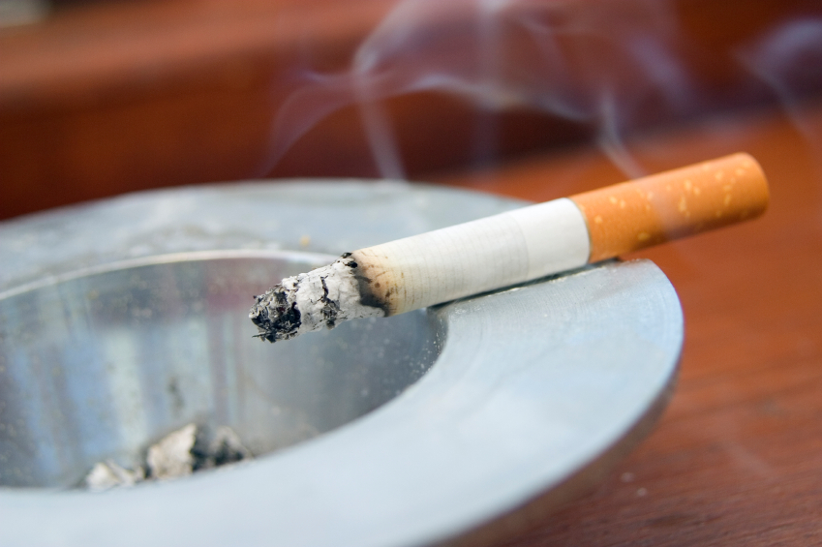  Calms you down
Cannabis | It gives you a high  
_________
2. What happens when you do drugs? Work with a partner. Use the words above and / or phrases from Resource 2 to help you. Use your own idea for the last box.

Resource 2 (cut-ups)
They make you feel relaxed
They can make you vomit
They can make you sweat or shiver
It calms you down
It makes you aggressive
You can stop breathing
It makes you dizzy
You can faint
You can choke
It gives you a high
It makes you more confident
It can make you shake

Resource 3 (Entry 2/ 3) Read about Craig and answer the questions below.
1 I started using the party drug ecstasy at weekends when I was about 17. I used to go to rave parties with my mates from college. We always took ecstasy so we could dance non-stop all night. It made us feel great. Afterwards, we used to go to someone's house to come down off the ecstasy.



2 We kept seeing this older guy at the house. After a few visits, we started talking to him and asked him what he was smoking. He told us it was 'brown' – heroin-and it helped him to chill out after dancing all night on ecstasy. He offered us some - it was good! It gave you a nice warm feeling. You didn't get the usual headaches and the bad moods, or feel down and depressed.

3 In six months, I needed heroin every day. I was addicted. One by one, I found out all my friends were buying from the dealer too! I'm the only one left now. All those friends are dead and I've wasted my whole life…I've never had a serious relationship, I've never had children and I'm 42 now. Heroin took the last 25 years of my life. I've tried so hard to stop using it. My parents tried too, but nothing worked. My dad even took me to Florida to a detox clinic for heroin users, but I started using drugs again as soon as I got home. Sadly, my dad died last year and now it's just my mum who keeps trying to help me. I broke my dad's heart and I can never say sorry to him now.

4 I wanted to get myself sent down to prison. I realised this was the only place I could get help for my addiction. Since I came here, I feel like I've gone back in time 25 years. I've even grown my hair long, like it was years ago when I was with my mates. When I look in the mirror now, I see the old me again. I'm clean now. I want to stay that way and help others to stay clean too. When I get out in eight months, I want to start again, have a normal life, a girlfriend, maybe a child…who knows?

Resource 3 (Entry 2/ 3): Questions

- What would be the best title for this story? Tick one of the titles below.
Compare with your partner and explain your choice.
- Prison has helped me to be free
- I wasted my life on drugs
- The dangers of drug addiction

- Read the sentences about Craig. Are they true or false?
Write T for the true sentences and F for the false ones.

- Craig is 25 years old.
- Craig used ecstasy and heroin.
- Craig was addicted to ecstasy.
- Craig was an addict for six months.
- Craig wanted to go to prison.
- Craig's family didn't help him.
- Craig's old friends are dead.
- Craig's girlfriend wants a baby.

- Read the text again. Answer the questions.
- How old was Craig when he started using drugs?________________
- What did he and his friends do at the weekends?________________
- Where did he meet the heroin dealer?_________________________
- Why did they try heroin?____________________________________
- How long was it, before they all became addicts?_________________
- How did his father try to help him?_____________________________
- What are Craig's hopes for the future?_________________________

Resource 3 (Entry 2 / 3): Questions continued
Vocabulary
4. Look at the underlined words in the text. Choose the best words in brackets to replace them:
- After the raves, we used to go to someone's house to come down off the ecstasy.
[sit down] [feel normal again] [feel sick]
- It helped him to chill out after dancing all night on ecstasy.
[sleep] [relax] [stay awake]
- You didn't get the headaches and the bad moods, or feel down.
[get angry] [get tired] [get depressed]
- I got myself sent down,
[put in prison] [depressed] [put on the ground floor]

5. Match the words from the text with their meanings.
- brown [paragraph 2] | - someone who sells drugs
- rave [paragraph 1] | - a place for addicts to stay while they stop using drugs
- dealer [paragraph 3] | - heroin
- detox clinic [paragraph 3] | - not addicted
- clean [paragraph 4] | - dance party

6. Discussion
Work in a group
- What do you think about Craig's life before he started using drugs?
- What do you think about Craig's future?
- Will he stay clean? Why? Why not?


Resource 3 (Entry 1) Craig's story

- When did you start using drugs?
When I was about 17 or 18.
- Why?
I used to go to parties at weekends with my mates from college. We always took some ecstasy so that we could dance all night.
- How did ecstasy make you feel?
It made us feel great and full of energy!
- Why did you start taking heroin?
We took it after the parties to relax. Ecstasy gave us energy, but then we were very tired.
Heroin made us feel good again.
- When did you know you had a heroin addiction?
We didn't know anything about drugs or addiction. At first it was ok. I only used heroin at weekends, after the parties. But after six months, I had to buy heroin every day. I was an addict.
- Did anyone help you to stop using heroin?
Yes. My parents always tried. My father took me to Florida, to a clinic for heroin addicts. But I started using heroin again when I got home to England. Finally, the best help I got was here in prison.
- How many years were you addicted to heroin?
I was an addict for 25 years. Now I'm clean at last!
- What do you want to do in the future?
I'm 42 years old and I want a normal clean life - a girlfriend, maybe a child…everything I missed because of heroin!

1. What would be the best title for this story? Tick one of the titles below. Compare with your partner and explain your choice.
a. Prison didn't help me | b. I wasted my life on  drugs | c. The dangers of going to d dance parties

Resource 3 (Entry 1): Questions continued
2. Read the sentences about Craig. Are they true or false?
a. Craig is 25 years old. | d. Craig was an addict for six months.
b. Craig used ecstasy and heroin. | e. Craig's family didn't help him.
c. Craig was addicted to ecstasy. | f. Craig's girlfriend wants a baby.

3. Read the text again. Complete the sentences about Craig.
- [question 1] I started using drugs when I was __________.
- [question 2] Every weekend, I went ____________ with my friends from college.
- [question 4] We took heroin after parties to make us _________ _________ again.
- [question 5] After ______ ________ I had to buy heroin every day.
- [question 6] My father took me to a _________ clinic in Florida.
- [question 8] In the future, Craig wants __________________________________.

4. Grammar
Craig's story is about his life in the past. Here are some verbs from his story, in the present tense. Read the text again. Can you find the verbs in the past tense?
Present | Past | Present | past
I am | I was | We don't know | We didn't know
It makes |  | I get help | 6.
We take |  | I use | 7.
We can |  | I have to | 8.
It gives |  | I start | 9.
My parents try |  | I miss | 10.

Resource 3 (Entry 1): Questions continued

5. Complete the sentences about Craig with the past simple verb in brackets.
- I _________ using drugs when I was about 17 or 18. [start]
- My friends and I always ____________ ecstasy so that we could dance all night. [take]
- Ecstasy _________ us energy! [give]
- Heroin __________ us feel good again. [make]
- We _______ ________ anything about drugs or addiction. [don't know]
- After six months , I _________ buy heroin every day. [have to]
- My parents always ___________ to help me. [try]
- I _________ help in prison. [get]
- I ________ an addict for 25 years. Now I'm clean at last! [am]

6. Discussion
Work in a group
- What do you think about Craig's past?
- What do you think about Craig's future?
- Will he stay clean? Why? Why not?

Extension activities: Resource 4 – Staying safe.
Craig got this information from the detox clinic. It will help him when he leaves prison.
1. Read the leaflet and complete the table below with the advice.
7 steps to stay safe from overdose on release
Action 1- get help
The best way to stay clean and safe is to get help from your local drug service. Even if you start using again, they will still help you.
Action 2- get treatment
If you start using drugs again, a prescription for methadone will help you with the withdrawal, so you can stay off drugs.
Action 3 – don't inject
Smoking heroin is safer than injecting it. People who inject are more likely to die from an overdose.
Action 4- don't mix drugs
Most overdoses happen when people mix drugs, like alcohol and heroin.
Action 5- don't use alone
If you are using drugs, try to use them with someone you trust. If you use alone, tell someone, so they can check on you.
Action 6 – agree to call for an ambulance
If you use with other people, agree to call an ambulance if anyone overdoses.
Action 7- get some training
Find out if your local drug services can give you overdose training

Do | Don't
- get help (from your local drug service) | - inject drugs

Resource 4 (continued)
2. Vocabulary
Read the leaflet again and choose the best meaning for the words below.

- stay clean | a stay off drugs | b shower often | c wear clean clothes
- overdose | a work too hard | take too much of a drug and get sick | c feel tired
- relapse | a feel calm and happy | b stop using drugs | c start using drugs again
- withdrawal | a take money out of the bank | b problems when you stop taking drugs | c very quiet
- drug service | a a place to buy drugs | b a place to get advice and information about drugs | c a place where you can buy medicine

3. Discussion
- What do you know about withdrawal and how it makes people feel?
Some people get a very bad stomach ache.
You can shiver or feel very cold

- What do you know about overdose?
You can stop breathing
You can choke

- Think about the words on worksheet 1, that you learned in the video.
- How do people feel when they stop using addictive substances, e.g. nicotine, alcohol or street drugs like cocaine or heroin?
Extension activities: Resource 5 – Project
Find out:
Who can help if you want advice about drugs and alcohol?
Where do you go for more information?
What courses are there in this prison for:
- stopping smoking
- alcohol abuse
- drug addiction
What about after release?
Write your answers in the table
help/ information | courses | after release

Unit 6 Living with addictions answers
Resource 1: symptoms video

- cough
- sneeze
- vomit
- shake
- sweat
- shiver
- faint
- choke

Resource 3 (Entry 2-3)
1.
A. Yes, because Craig has finally succeeded in breaking his addiction after 25 years
B. Yes, because he never had a girlfriend or children or a normal life
C. Yes, because his experience was very bad, but it could have happened to any young person.

2.
a.f
b. t
c.f
d.f
e.t
f.f
g.t
h.f

3.

a. 17 or 18
b. go to raves
c. in a house
d. to relax after the ecstasy
e. 6 months
f. his father took him to a detox clinic in Florida
g. a normal life, girlfriend, maybe a child

4.
a. feel normal again b. relax c. get depressed d. put in prison
5.
1 c 2.e 3 a 4.b 5.d

Resource 3 (Entry 1)
1.b. I wasted my life on drugs - because he never had a girlfriend, children or a normal life
2. a. f b. t c. f d. f e. f f. f
3.
a. I started using drugs when I was(about) 17 or 18
b. Every weekend, I went to parties with my friends from college.
c. We took heroin after parties to make us feel good again.
d. After 6 months I had to buy heroin every day.
e. My father took me to a detox clinic in Florida.
f. In the future, Craig wants a normal clean life/ a girlfirend/ maybe a child
4. Grammar
I was we didn't know
1. it made 6. I got help
2. we took 7. I used
3. we could 8. I had to
4. it gave 9. I started
5. my parents tried 10. I missed

5. a .started
b. took
c.gave
d.made
e.didn't know
f.had to
g.tried
h.got
i.was
Resource 4: staying safe
Do | Don't
get help (from your local drug service) | inject drugs
get treatment (e.g. a methadone prescription) | mix drugs(most overdoses happen if you mix drugs)
agree to call an ambulance( if anyone overdoses) | use alone (tell someone to check on you)
get some training (about overdosing)
2. Vocabulary
1a. 2b. 3c. 4b. 5b.

